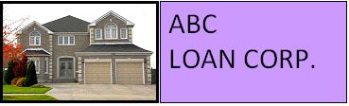

We offer 15-year fixed rate loans.

15-Year Fixed-Rate
This type of loan offers higher monthly payments, however you pay less interest over time and you build equity faster. This loan type is a good choice if you want to own your home sooner and can afford higher payments during this timeframe.
Based on your down payment, credit rating, and processing fee options, the interest rate for 15 years is:

 | 2% Fee | 1% Fee | 0% Fee
Conventional | 5.25% | 5.5% | 5.75%
Non-conventional | 5.75% | 6.0% | 6.25%

Interest rates are subject to change. Please contact our loan officer for the latest rates.

1-800-ABC-LOAN

info@mymail.com

